Exanimating use of different Procedural Animation techniques in Commercial Video Games and applying them to a Character in Unreal Engine 5.

By Jack Hopkins [180246647]

Project Supervisor: Dr Gary Ushaw

Number of Words: ------.

# Abstract

With the advancement of computing technology and the growth of video game market, more and more developers have started to use procedural generation within their games. One more novel use is for animation. This paper will be examining different applications and implementations of it in the industry and the body of literature surrounding, this research will be then used to create an animated character in Unreal Engine 5.

Contents

Abstract 1

1 Introduction 4

1.1 Original Aims & Objectives 5

1.1.1 Objectives 5

1.2 Project Outline 5

2 Background Technical Material 6

2.1 Procedural Generation 6

2.2 Land Use Models (LUMs) 7

2.3 Flood Fill Algorithms 9

2.4 Four Way 9

2.5 Span Filling / Scanline 9

2.6 Painter / Walk Based Filling (Fixed-memory method) 11

3 Implementation 14

3.1 Overview 14

3.2 BuildingGenerator.cs 20

3.3 FloodFill.cs 23

3.4 Brute Force 23

3.4.1 Pseudo-Code: Brute Force 23

3.5 FourWay.cs 23

3.5.1 Pseudo-Code: Recursive Implementation 24

3.5.2 Pseudo-Code / Code: Linear Implementation 24

3.6 SpanFill.cs 25

3.6.1 Pseudo-Code: Scan Line 25

3.7 WalkBasedFilling.cs 26

3.7.1 Pseudo-Code: Painter / Walk Based Filling 26

3.8 PerimeterCheck.cs 29

3.8.1 Pseudo-Code: PerimeterCheck: 29

3.9 Other Technologies / Assets used 29

3.9.1 Trello 29

3.9.2 GitHub (Version Control) 30

3.9.3 Polygon Knights Asset pack 30

4 Results and Evaluation 32

4.1 Stack vs Queue 32

4.2 Algorithm Speed Tests 34

4.2.1 Circle and Square Test 34

4.2.2 Test Town 39

4.2.3 Checkers Test 41

4.2.4 Algorithm Speed: Summary 43

4.3 Memory Use Tests 43

4.3.1 GC Alloc Used Comparison 44

4.3.2 GC Alloc Used 45

4.3.3 GC Alloc Used per Microsecond 46

5 Conclusion 47

6 Appendix 48

6.1 Table of Figures 48

# Introduction

As the industry continues to grow and computing power continues to progress, the use of procedural generation in video games has become more valuable, not only to expedite the development process, but to also to create more dynamic mechanics and as a tool for creative expression.

One of these avenues of procedural generation can be seen in animation. This can range from very simple things like turning head, such as Quake III, * to animating entire custom characters which are made in game, as in Spore. [1] [2]

Animation is a time-consuming process and, when done manually, is often not adaptive. This can create many situations when the animation breaks the immersion of the player. One of the most common issues with foot placement on different terrain within walk cycles. [3]

Procedural animation is a large umbrella term that covers many techniques ranging simple ragdoll physics, to inverse kinematics (IK). It’s rare to see only on used in a video game and instead many use a plethora of methods to get a result the developers are happy with. One example of this would be *Rain World,* where the developers chose to use rigid bodies and pathfinding to animate their character. [4]



Figure . Gif of 3 different Rain World characters. All animated with procedural generation.

The project will go beyond existing works by focusing on the compilation of multiple different techniques in order to create a fully animated character. I will be using as many techniques as I can and explain my decisions to why I’m using all of them in each specific scenario.

This project is motivated by my interest in animation and my curiosity in the world of procedural animation. I also want to become more familiar with Unreal Engine 4 because it uses C++ and I’ve yet to use it for a big project.

As we proceed through this dissertation, you will see me apply [Insert techniques used and results]

This project will be suing technologies such as:

* Unreal Engine 4 for its Control Rig and in-depth online tutorials.
* Blender to create the skeletal rig.
* GitHub for version control.

## Original Aims & Objectives

### Objectives

#### Examine and learn different applications of Procedural Animation.

Discuss applications of procedural animation in the current literature and applications of it in released video games.

#### Learn and understand Unreal Engine’s Control Rig tool.

It is vital I understand how to use the Unity Engine, its preferred language C++ and Blueprints. Develop knowledge and understanding of animation blending, delineation, skeletal animation, ragdoll and more.

#### Implement procedural animation methods.

Use Unreal Engine 4 to create animations for a bipedal character doing multiple motions such as walking, running, jumping and crouching.

#### Evaluate results and test prototype.

Compare the prototype to other implementations in commercial video games, analysing it’s strengths and weakness. Stress test with multiple numbers of moving characters testing the amount of memory used and framerate of the game.

## Project Outline

Introduction

*An introduction to the dissertation detailing the motivation, aims, objectives as well as the initial problem.*

Background and Research

*Presents the context and background research done for the project.*

Implementation

*A discussion on what the prototype can do and how I went about implementing the background research into it.*

Results and Evaluation

A section on displaying and analysing the results of each FFA procured from the prototype.

Conclusion

A summary on the fulfilment of objectives, summary of the achievements of the project, development of personal skills, and possible future work.

# Background Technical Material

Within this chapter, I will be discussing the background research that went into my project. Starting with a broad overview of the literature on procedural animation, examine different techniques used in commercial video games and analyse the techniques benefits and detriments.

Talk about Procedural Animation uses:

* I can make more realistic and adaptive environments
* Artistic style
* Speed and pace.
* Mix with other types of animation.

## Procedural Animation

Character animations are, in most games, premade assets; ones created beforehand by and artist. Whether they are crafted by hand, drawn frame by frame [5], or using motion capture [6], all these animations are predetermined. This means that games may require an extraordinary number of animations for all the different situations a player might find themselves in. This of course depends on the video game, but even in Mario 64, Mario has 209 different animations [7]. And this was a game released in 1996 when the standards and size of animation was not as great as it is now.

Granted, the number and scale of animations can vary greatly upon genre, development team size, etc. but the point being that expediting the process of animation creation has begun to see more and more use. This is one of the general draws of procedural generation. It widens the horizon of possibilities for games developers to exercise their creative authority. Whether it be, reactive music [8], or inimitable storylines or unique worlds for each playthrough [9]; all these things [10] - as Tanya X. Short et al put it:

[Allows] Players [to] have their own personal journey but still have enough common experience to share their tales with others… [11]

### Passive Animation

When it comes to procedural animation, they can be divided into two main categories: passive and active. The key difference between them being whether they require sophisticated controls to make them appear natural. [12]

Passive animation does not use a controller and often can instead use physics simulations. This has led to passive animations to be quite successful as they’ve provided complex detail where hand animation, or data capture is difficult. [12]

#### Particle and Visual Effects

One the earliest examples of procedural animation can be seen in particle effects [13] and fluid dynamics. These animations often rely on the physics engine to process many different particles in a short period. These are done procedurally because recreating them with conventional rendering techniques can be difficult since they are usually highly chaotic systems based on natural phenomena. Furthermore, these systems are also very reactive so having them generated at runtime allows them to be applied to multiple situations saving on development time. However, these can be stylised too with multiple different shader and visual effects.

#### Best Dillongoo GIFs | GfycatHow to Create Particle Effects That Emit Light in Niagara for Unreal Engine | Unreal Engine DocumentationRagdoll Physics

Figure . "Mesh Trail" a custom VFX plugin. [56]

Figure . Particle Effect demonstration in Unreal Engine 5 [57]

### Active Animation

Having character-based animation has been a much more recent investment in the video game field. This can be seen in games like *Spore*, a progenitor of modern-day real-time animation. [1] [14] Avatars within Spore were created by the player. This customisability made it impossible to premade all the animations, thus the Maxis team use procedural animation. One technique to get the characters to walk and run convincingly was to create multiple heuristics to generate movement. An example would create a *walking ratio* from the number of legs, body length and bodily symmetry. From this a gait and walking rhythm could be calculated to result in a more lifelike motion. [14]



Figure . Weird Alien creature from Spore [15]

# Implementation

This chapter will detail the journey of the project’s implementation from start to finish.

**TYPES OF IMPLEMENTED ANIMATION:**

* **AUTOMATED FOOTHOLDS (FIXING FEETSKATE)**
* **RAGDOLL**
* **REACTIVE / PARTIAL RAGDOLL**
* **ANIMATION BLENDING**
* **AUTOMATED HEAD TURNING -> TORSO TURNING**
* **PARTICLE EFFECT**

## OVERVIEW

At the start of my implementation, I had to select how I wanted to approach the project:

* either attempt to implement it at a low-level, with technologies such as OpenGL and pure C++.
* or at a more high-level with technologies such as the Unreal Engine.

While it is always tempting to try and deepen my skill in C++ and OpenGL it would be at the cost of the overall project. The main aim of this project is to investigate a wide range of techniques and then implement a few of them within a singular character to further understand their utility. Thus, using an already establish engine such as Unreal Engine 5, made the most sense.

Within the industry, Unreal Engine 5 is receiving a lot of buzz, particularly in the triple-A development scene. It, also, supports the use of C++, a language I’m more comfortable with.

## AUTOMATED FOOT PLACEMENT

Early on I found a helpful plugin for Unreal Engine called Control Rig, this gives access to the blueprint style interface where you can define how a skeletal mesh should behave. This allows for the implementation of inverse kinematics and the creation of an automated foot placement system. I can then use the main blueprint interface to precisely call when I wanted it.

## / Assets used

### Trello

Over the course of the project, I used Trello for project management. It allowed me to work in an agile way with a Canban-Sprint style of workflow (bi-weekly sprints). The point system allowed me to measure my velocity to see my current progress and rate of work.

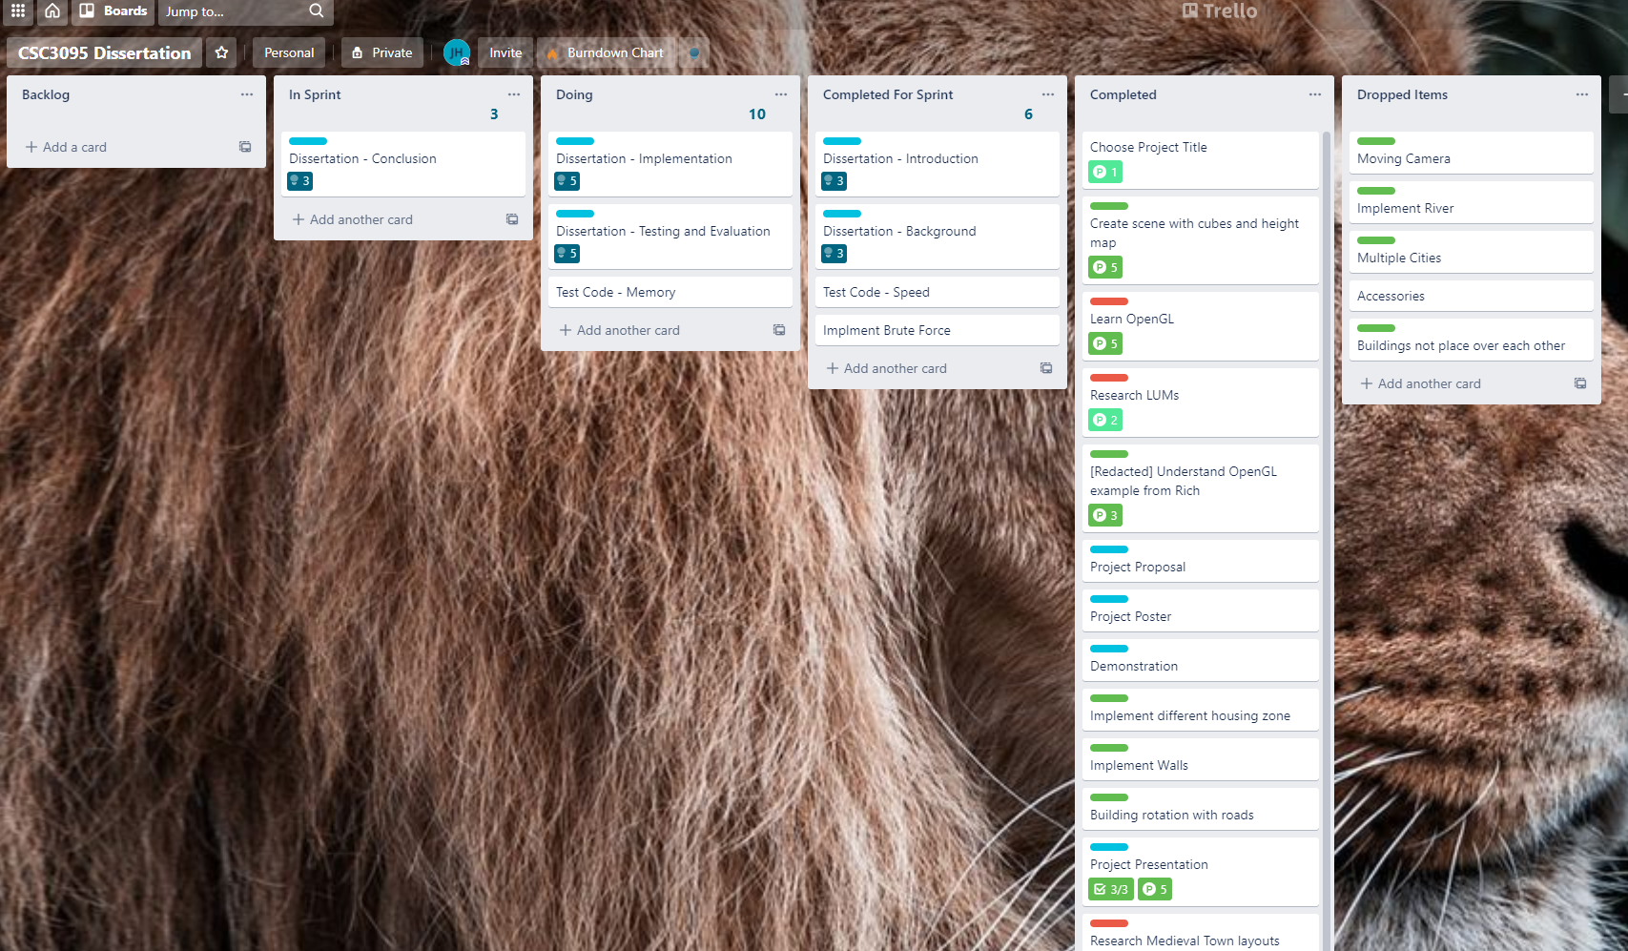

Figure . Picture of my Trello board

### GitHub (Version Control)

I was working from many different stations, whether it be at home, or on campus at either the Urban Science Building or Fredrick Douglas. Github and Git Bash allow me to seamlessly update my directories and work on multiple parts of the project at once using different branches and pull requests. Furthermore, it allowed me to go back a take pictures of my progress once I started writing my dissertation. It acted as a contingency plan if I lost my work for whatever reason.

Figure . GitHub repository

# Results and Evaluation

# Conclusion

# Appendix

## Table of Figures

# Bibliography

|  |  |
| --- | --- |
| [1] | Spore, Electronic Arts, 30 May 2008. [Online]. Available: https://www.youtube.com/watch?v=6dilwN8mN6s. |
| [2] | C. a. R. B. a. E. R. W. a. D. J. a. M. J. a. v. P. K. Hecker, “Real-time motion retargeting to highly varied user-created morphologies,” *ACM Transactions on Graphics (TOG),* vol. 27, pp. 1-11, 2008. |
| [3] | R. S. Johansen, “Automated semi-procedural animation for character locomotion,” *Aarhus Universitet, Institut for Informations Medievidenskab,* 2009. |
| [4] | J. Jakobsson and J. Therrien, “The Rain World Animation Process,” 16 July 2017. [Online]. Available: https://www.youtube.com/watch?v=sVntwsrjNe4. |
| [5] | C. Jake, “Cuphead's Animation Process and Philosophy,” GDC, 17 August 2017. [Online]. Available: https://www.youtube.com/watch?v=RmGb-jU3uVQ. |
| [6] | S. David, “The Motion Capture Pipeline of The Last of Us,” GDC, 18 December 2016. [Online]. Available: https://www.youtube.com/watch?v=2GoDlM1Z7BU. |
| [7] | The Cutting Room Floor, “Super Mario 64 (Nintendo 64),” April 16 2022. [Online]. Available: https://tcrf.net/Super_Mario_64_(Nintendo_64)#:~:text=Mario%20has%20a%20total%20of,indexed%20from%200%20to%20208.. [Accessed 22 April 2022]. |
| [8] | D. Plans and D. Morelli, “Experience-driven procedural music generation for games,” *IEEE Transactions on Computational Intelligence and AI in Games,* vol. 4, no. 3, pp. 192-198, 2012. |
| [9] | J. Freiknecht and W. Effelsberg, “A Survey on the Procedural Generation of Virtual Worlds,” *Multimodal Technologies and Interactio,* vol. 1, no. 4, 2017. |
| [10] | M. Brown, *How the Nemesis System Creates Stories,* Game Maker's Toolkit, 2021. |
| [11] | T. Short and T. Adams, Procedural generation in game design, CRC Press, 2017, p. 1. |
| [12] | A. a. Z. V. Hertzmann, “Physics-based characters,” *IEEE Computer Graphics and Applications,* vol. 31, no. 4, pp. 20-21, 2011. |
| [13] | W. T. Reeves, “Particle Systems - A Technique for Modeling a Class of Fuzzy Objects,” *ACM Transactions on Graphics (TOG),* vol. 2, no. 2, p. Particle SystemsmA Technique for Modeling a Class of Fuzzy Objects, 1983. |
| [14] | D. Kushner, “Engineering Spore,” *IEEE Spectrum,* vol. 9, no. 45, pp. 36-40, 2008. |
| [15] | DillonGoo, “Mesh Trails Add-on,” 15 December 2021. [Online]. Available: https://www.dillongoo.com/products/mesh-trails. |
| [16] | Epic Games, “Particle Lights - Unreal Engine 5.0 Documentation,” Epic Games, [Online]. Available: https://docs.unrealengine.com/5.0/en-US/how-to-create-particle-effects-that-emit-light-in-niagara-for-unreal-engine/. |